**3.3 Maven Setup**

This section will guide you to:

* Configure build tools and JDK versions

This lab has two sub-sections, namely:

3.3.1 Configuring the Maven setup

3.3.2 Configuring the JDK

**Step 3.3.1:** Configuring the Maven setup

* Open the Jenkins dashboard.
* Click on *Manage Jenkins*. From the list of options, choose *Manage Plugins*.

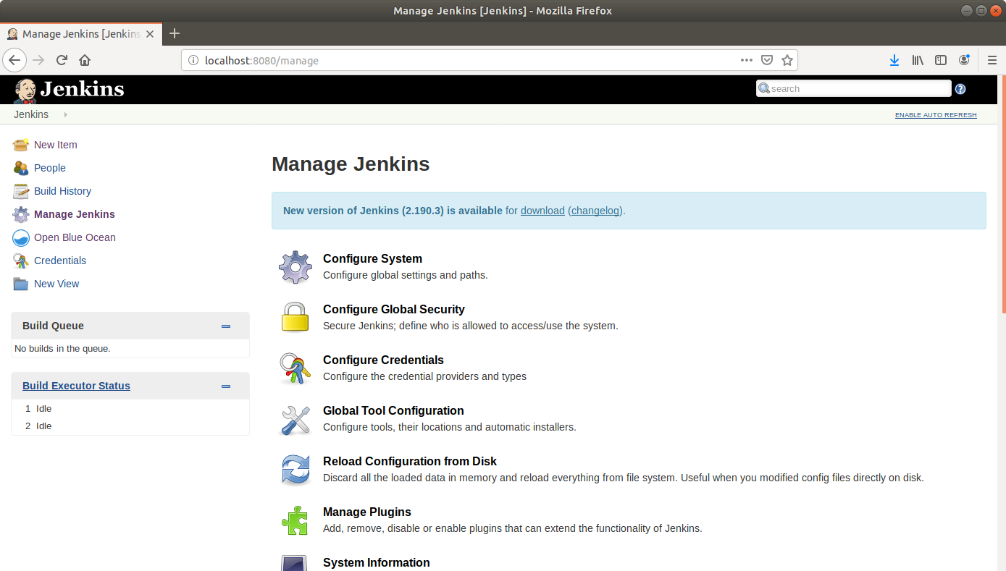

* Under the *Available* tab, select *Maven Integration*.

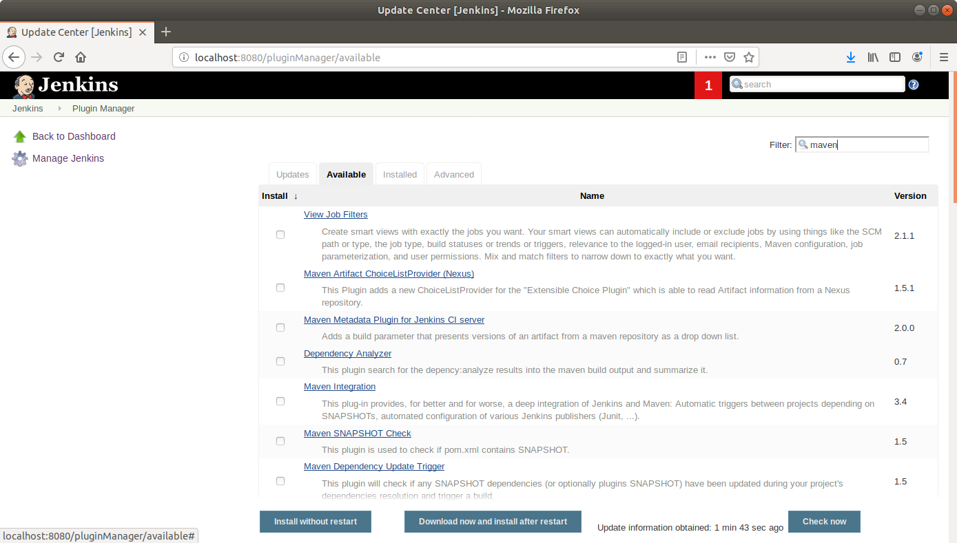

* Click on *Install without restart* and the plugin will be installed.

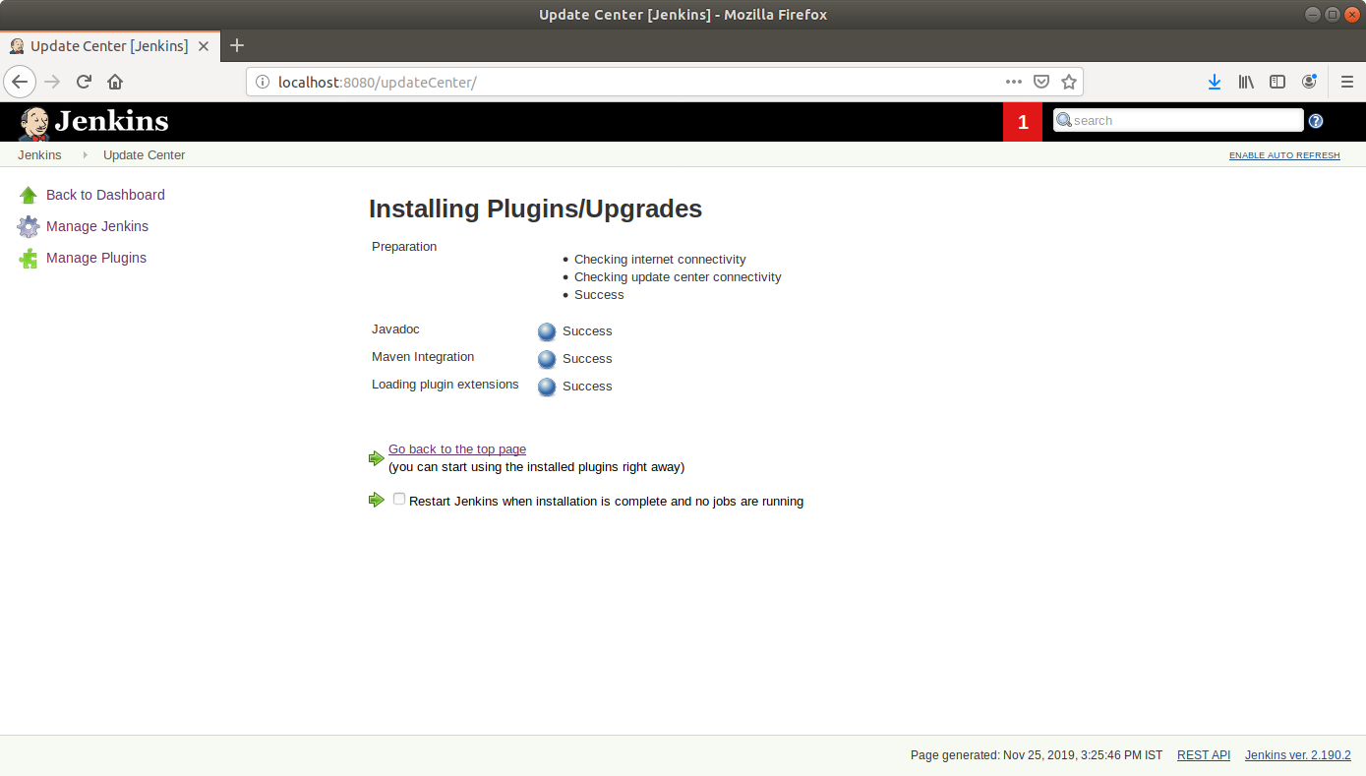

* Go to <https://maven.apache.org/download.cgi> and download the binary zip file.

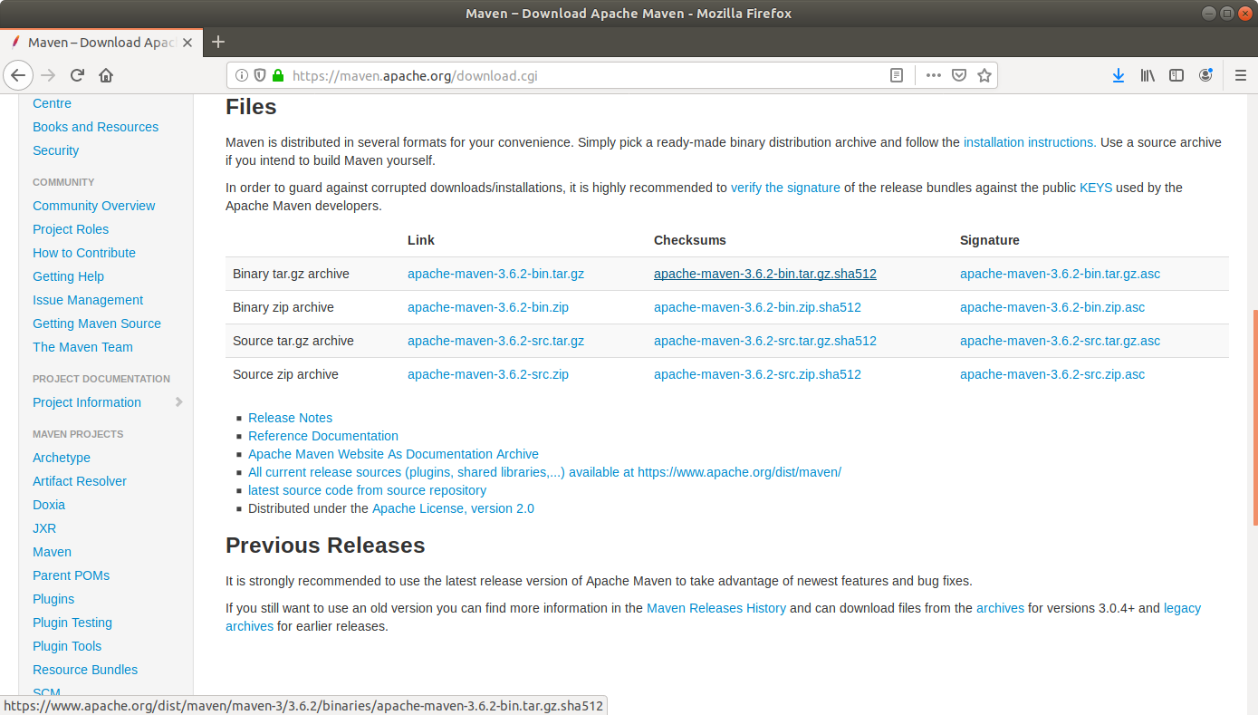

* Unzip and extract the file and copy the path.
* Go to *Manage Jenkins* from the Jenkins dashboard and select *Global Tool Configuration.*
* Scroll down to the *Maven* section and click on *Add Maven*.

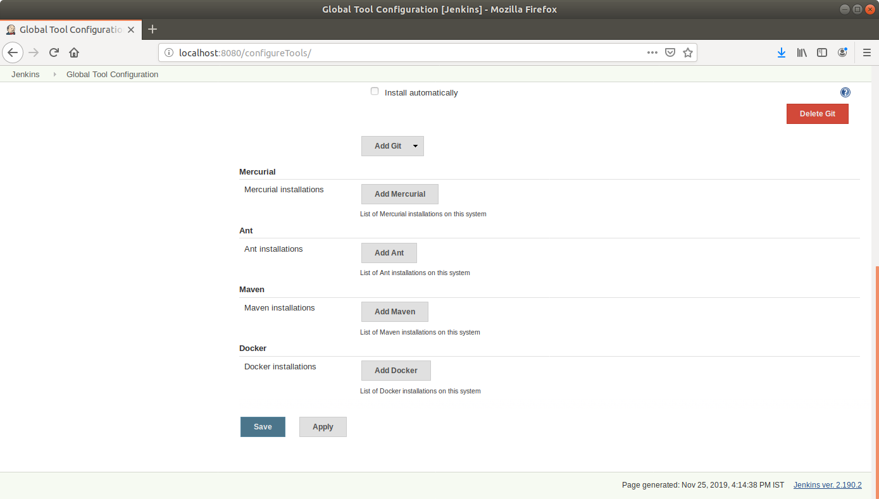

* You can choose to install automatically by ticking the checkbox and specifying the version, or uncheck the box and enter the local path if you want to configure manually.
* Enter a name for the installation.
* Uncheck the *Install* *automatically* checkbox.
* Paste the path to the Maven file in the *MAVEN_HOME* field and click *Save*.

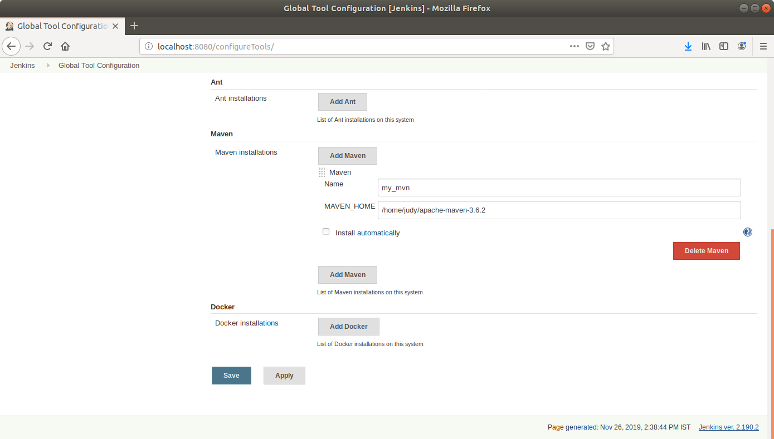

* You can now find *Maven* *project* as an option under *New Item*.

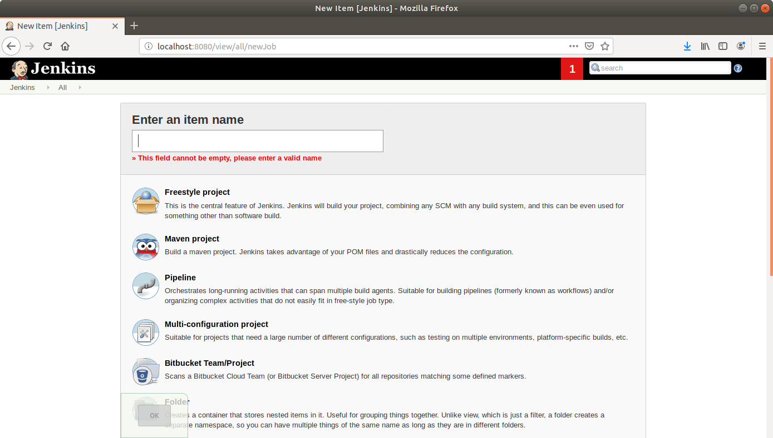

**Step 3.3.2:**  Configuring the JDK

* Go to *Manage Jenkins* from the Jenkins dashboard and select *Global Tool Configuration.*
* Scroll down to the *JDK* Section and click on *Add JDK*.

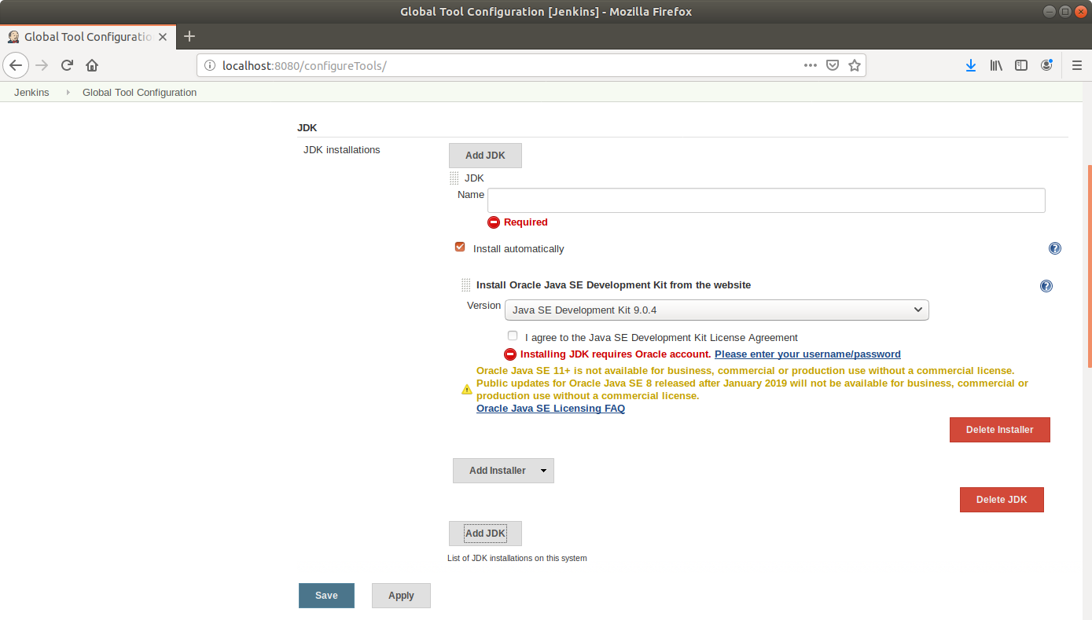

* You can choose to install automatically by ticking the checkbox and specifying the version. Uncheck the box if you want to enter the JDK path manually.

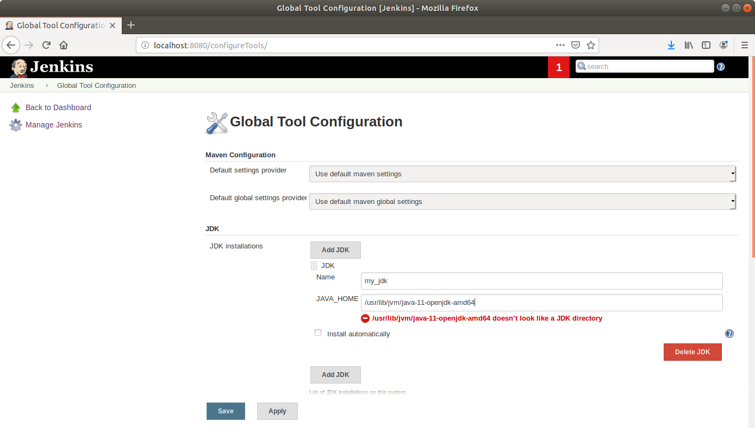

* Enter the path to the JDK in the JAVA_HOME field and click *Save*.